**VEGF follow up paper**

**Abstract**

Neural crest cells are an excellent model to study long distance cell migration during embryonic development. Neural crest cells are sculpted into multicellular streams near the dorsal neural tube, but it is largely unclear what mechanisms direct cells through distinct microenvironments to reach distal targets. Previously, we discovered a chemotactic role for vascular endothelial growth factor 165 (VEGF) and developed a cell-induced gradient model for cranial neural crest migration. In this model, lead neural crest cells respond to VEGF and transfer guidance information to trailing cells. Here, we test this model by challenging the VEGF chemotactic profile both in the chick embryo neural crest microenvironment and in silico using our agent-based computational model. First, we determine the influence of the embryonic microenvironments and VEGF on neural crest cell molecular profiles and show that lead and trailing molecular profiles do not exist when neural crest cells migrate outside the embryo. In vivo transplantation experiments of VEGF cells adjacent to trailing neural crest cells resulted in some cells diverting towards the ectopic VEGF source but most trailing neural crest cells preferred to remain within the migratory stream. Interestingly, trailing neural crest cells diverted towards the ectopic VEGF source have a molecular profile that becomes more similar to lead neural crest cells. Finally, to maintain their collective migration within the migratory stream trailing neural crest cells to do require VEGF. These results suggest that the molecular profile and behavior of neural crest cells are very dynamic and highly dependent on surrounding embryonic microenvironments.

ADD IN COMPUTATIONAL

**Introduction**

Critical to long distance cell migration is the cells’ ability to interpret intercellular signals (Uriu et al., 2014). In an embryonic setting, cells do not migrate through empty space but rather through different microenvironments. Their surrounding microenvironments are comprised of other cells, of different or similar types, as well as components of the ECM, including secreted molecules (Perris and Perissinotto, 2000; Uriu et al., 2014). Neural crest cells migrate long distances from the dorsal neural tube in a very precise manner to colonize specific target destinations (Alfandari et al., 2010; Clay and Halloran, 2010; Gammill and Roffers-Agarwal, 2010; Kirby and Hutson, 2010; Klymkowsky et al., 2010; Kulesa et al., 2010; Kulesa and Gammill, 2010; Lake and Heuckeroth, 2013; Newgreen et al., 2013; Powell et al., 2013; Theveneau and Mayor, 2012). A long standing debate is understanding how much of the neural crest cell behavior and composition is predetermined prior to their migration into and throughout embryonic microenvironments as opposed to plastic and influenced by their local microenvironments. Clearly neural crest cells are specified to be neural crest cells prior to their delamination from the neural tube, but during migration, not all neural crest cells are equal and so the question is how much of the behavior and composition of individual neural crest cells is predetermined versus plastic.

Previously, VEGF was shown to act as a chemoattractant for neuropilin-1 expressing cranial neural crest cells (McLennan et al., 2010). Neuropilin-1 is a functional receptor for VEGF as well as other ligands (Prud'homme and Glinka, 2012). When neuropilin-1 expression was knocked down in cranial neural crest cells, they failed to migrate the complete distance of their migratory route (McLennan and Kulesa, 2007). VEGF is expressed by and secreted from the ectoderm overlaying the cranial neural crest cell migratory route and attracts cranial neural crest cells both in vitro and in vivo in a neuropilin-1 dependent manner (McLennan et al., 2010).

Computational modeling run in parallel with biological experiments suggested that the cranial neural crest migratory stream was composed of at least two subpopulations, leaders and trailers (McLennan et al., 2012). That is, not all neural crest cells are the same, but rather their behavior and composition is different depending on location within the migratory stream (McLennan et al., 2012). In the computational modeling, leaders were defined as responding to the VEGF chemoattractant while trailers respond to, and follow, other neural crest cells (McLennan et al., 2012). Transplantation and ablation experiments suggested that the behavior and composition of cranial neural crest cells was highly plastic (McLennan et al., 2012).

What remains to be determined is whether lead and trailing neural crest cells exist in the absence of the embryonic microenvironments, and how much of a role VEGF plays on trailing neural crest cell migration in the embryological setting. Here, we grow neural crest cells in culture, test their molecular profiles for the existence of lead and trailing neural crest cells in vitro and examine their temporal responses to VEGF. We then applied the temporal responses to VEGF to our computational modeling and moved biological experiments into the embryo. To test whether trailing neural crest cells can respond to VEGF in vivo, we placed ectopic sources of VEGF either adjacent or within the trailing portion of the stream and examined resulting behaviours and molecular profiles. To test whether trailing neural crest cells require VEGF for proper collective maintenance, we knocked down VEGF production from the overlaying ectoderm as well as bound up endogenous VEGF protein in the mesoderm. Finally, we examined what effect knocking down VEGF signaling has on lead neural crest cell molecular profiles. Our results highlight the necessity of the embryonic microenvironment for creating lead and trailing neural crest cell molecular profiles as well as the power of VEGF in attracting neural crest cells with leader-like gene expression.

ADD IN COMPUTATIONAL

**Materials and methods**

**Embryos and in ovo cell labeling and transplants**

Fertilized white leghorn chicken eggs (supplied by Centurion Poultry Inc., Lexington, GA) were incubated at 38 °C in a humidified incubator until the desired HH (Hamburger and Hamilton, 1951) stages of development. For VEGF transplant experiments, premigratory neural crest were labeled by injecting Vybrant DiO (V22889, Invitrogen, Carlsbad, CA) into the lumen of the neural tube. Following re-incubation of 12 hours, clumps of DiI-labeled endothelial cells (control (CRL-2279, ATCC, Manassas, VA)) or VEGF-expressing cells (CRL-2460, ATCC) were transplanted either into or adjacent to the trailing portion of the migrating neural crest stream. The embryos were either re-incubated for 1 hour and then mounted on glass bottom dishes (P35G-1.5-20-C, MatTek Corporation, Ashland, MA) for timelapse imaging as previously described (Chapman et al., 2001; McKinney et al., 2013) or for 12 hours before being harvested for static imaging or cell isolations as previously described (McLennan et al., 2012). For VEGF signaling knockdown experiments, neuropilin-1-Fc (566-NNS, R & D Systems, Inc) targeted injections and neuropilin-1 siRNA electroporations were performed as previously described (Bron et al., 2004; McLennan and Kulesa, 2007). Control GFP (pMES) or fluorescently tagged VEGF morpholino (GeneTools, Philomath, OR) was targeted to the ectoderm overlaying the trailing portion of the stream by injecting a small amount of construct or morpholino immediately above the cranial ectoderm on one side of the embryo at HH St 9-11, and then electroporated with platinum electrodes placed either side of the embryo. After 24 hours re-incubation, embryos were fixed, cryostat sectioned and HNK-1 immunohistochemistry was performed as previously described (McLennan et al., 2010).

**In vitro assays**

Neural tubes containing premigratory neural crest cells were cultured as previously described (McLennan et al., 2010). For the lead/trail analysis, neural tubes were plated on nuclease-free 1.0 PEN Membrane Slides (415190-9081-000, Zeiss, Jena, Germany) so that neural crest cells would migrate onto the slides and be easily and selectively isolated. After 24 hours of incubation to allow for neural crest migration, slides were fixed with ethanol. Using a PALM Microbeam (Zeiss), neural crest cells adjacent to the neural tube (trailers) and at the edge of the migratory wave (leaders) were catapulted without contact into an Adhesive Cap (415190-9181-000, Zeiss), lysed and used for standard RT-qPCR on an ABI 7900HT Fast Real-Time PCR system (ABI). For the time course exposure to VEGF, neural tubes were plated on glass bottom dishes, one neural tube per dish. After overnight incubation, neural tubes were removed, leaving only neural crest rich cells. Ham’s F-12 Nutrient Mix Media (11765054, Invitrogen) containing VEGF was then added and replaced with plain media, which was then replaced with media containing VEGF in a temporal manner (Fig. 2A). Neural crest cells were lysed directly on the glass bottom dishes at different time points by replacing media with 10ul of Cells-to-Ct lysis solution containing 1:100 DNAse I (4387299, Life Technologies). Lysis was allowed to proceed room temperature for 15 minutes. The lysis reaction was halted with 1ul of Stop solution and samples were immediately placed on dry ice and stored at -80 C.

**Molecular profiling**

cDNA was synthesized directly from sample lysates (438814, Life Technologies) in reactions that included 1ul of RNAse inhibitor (N261b, Promega). Gene-specific targets were pre-amplified from a portion of the cDNA in 20ul preamp reactions using 14 thermal cycles according to a miniaturized version of Life Technologies’ Cells-to-Ct preamp kit (4387299, Life Technologies). Pre-amplified products were diluted with 1X TE before being analyzed by microfluidic RT-qPCR on Fluidigm’s Biomark HD platform. Non-logarithmic curves were manually removed in Biomark software. Data was normalized using three reference genes chosen from at least 6 candidates and analyzed with Biogazelle’s qBASE software. Partek’s Genomics Suite was employed for generating clusters, dissimilarity matrices and intensity plots.

**Fluorescent hybridization chain reaction on neural tube cultures**

Neural tubes were isolated and plated, 5-6 neural tubes per glass bottom dish and incubated overnight as previously described (McLennan et al., 2010). Cultures were fixed in 4% paraformaldehyde at room temperature for 1 hour and then dehydrated stepwise with an ethanol/PBS-T gradient. Cultures were left overnight in ethanol and then rehydrated stepwise into PBS-T. FoxD3, Hand2 and Bambi mRNA transcripts were visualized by multiplex fluorescent in situ hybridization (HCR) as previously described (Choi et al., 2010) and Profiling Paper) with a probe concentration of 2 nM and hairpins at a concentration of 30 nM. HCR-labeled cultures were imaged on a Zeiss LSM 780 confocal microscrope.

**Analysis of cell behaviors**

Polyline Kymograph jru v1 (a plugin created for Image J by Jay Unruh) was used to compute the average intensity of the DiO along the migratory route. A width of 50um was used for the polyline kymograph because the average width adjacent to the OV is 50um in control embryos. In order to compare all data sets, the distance along the route and the average intensity was normalized in Excel (Microsoft). The intensity was normalized for the highest intensity in each data set to account for differences of labeling intensity when averaging all data sets. The data was then imported into Matlab (Mathworks) and averaged using 1 % bins along the migratory route. The width of each r4 stream was measured adjacent to the middle of the transplant in AIM. In the control case it was measured at the middle of the OV. The length of each stream along the migratory route was measured in AIM and a percentage was calculated from the length of the BA. Cells were manually tracked in the time lapses using Imaris (Bitplane). Statistical analyses were performed using Students t-test or 2nd order ANOVA.

**Computational Modeling**

**Results**

**Lead and trailing molecular profiles are not predetermined but are the consequence of the embryonic microenvironments, including VEGF**

Using morphometric analysis and molecular profiling, we have previously shown that not all neural crest cells within a stream are the same, but rather a stream is composed of at least two subpopulations, leaders and trailers (McLennan et al., 2012). From transplant and ablation experiments, we hypothesize that leaders and trailers are the result of interactions with the surrounding embryonic microenvironments as well as each other (McLennan et al., 2012). Here we address whether those subpopulations are predetermined or the result of the surrounding embryonic microenvironments, we isolated neural tubes containing premigratory neural crest cells, allowed the neural crest cells to migrate out from the neural tube and then performed molecular profiling of lead and trailing areas. This experiment removes as many of the embryonic microenvironmental signals as possible. Hierarchical clustering shows that lead and trailing molecular profiles do not exist in vitro (Fig. 1A). Both lead and trail in vitro molecular profiles cluster most similarly with in trail in vivo (Fig. 1A). Euclidean dissimilarity matrix intensity plot shows that in vitro trail and in vitro lead are the most similar to each other (14.06) while in vivo trail and in vivo lead are the least similar to one another (28.65) (Fig. 1B). It is important to note that even though the in vitro samples are most similar to each other, they are still very different from one another as their score is not close to zero (Fig. 1B).

When the molecular profiles are compared at the individual gene level, there were 11 genes that were upregulated in the lead for both in vitro and in vivo, but only 1 gene, RUNX2, which was upregulated in both (Fig. 1C). There were 9 genes upregulated in the trail in vivo and 5 genes upregulated in the trail in vitro but only 1 gene, FOXD3, which was upregulated in both (Fig. 1D). Therefore even though there were molecular profile differences associated with lead and trail in vitro, they did not reflect the molecular profile differences seen in vivo.

To confirm this finding, we used fluorescent hybridization chain reaction (HCR) on neural tube cultures for markers of lead (HAND2, BAMBI) and trailing (FOXD3) neural crest cells in vivo (Fig. 1E). We found that, in vitro, FoxD3 was expressed at high levels in a large percentage of cells irrespective of location relative to the neural tube (Fig. 1E). Hand2 and Bambi expression, on the other hand, was minimal and not seen in high levels in cultured cells (Fig. 1E and Inset). No differential staining was seen to indicate distinct subpopulations in vitro, and there was very little similarity between expression of these markers in NT cultures and within the r4 migratory stream in the embryo.

To investigate whether VEGF exposure in culture can influence the molecular profile of neural crest cells, we exposed neural tube cultures to VEGF overnight. Hierarchical clustering shows that upon exposure to VEGF, lead and trailing molecular profiles now cluster closer with control lead as opposed to trailing (Fig. 1F). Euclidean dissimilarity matrix intensity plot shows that VEGF trail and VEGF lead are the most similar to control lead with scores of 14.80 and 22.62 respectively (Fig. 1G). These experiments demonstrate that lead and trailing molecular profiles are not innate, but rather a consequence to exposure to important signals within the embryonic microenvironments, one of them being VEGF.

**Neural crest cell genes respond to changes in VEGF within minutes**

VEGF acts as a chemoattractant and a proliferative agent for neural crest cells in culture (McLennan et al., 2010). Here we wanted to investigate how quickly neural crest cells can respond to VEGF in vitro. We performed a timed experiment where neural crest cells were initially exposed to VEGF for 2 hours. Then VEGF was removed for 1.5 hours and then reapplied for an additional 1.5 hours. Samples of neural crest cells for RNA isolation and profiling were taken at specific timepoints (Fig. 2A). When the expression of all genes was examined overtime, it was clear that different genes responded in different temporal manners to the exposures to VEGF (Fig. 2B). The different responses to exposures to VEGF can be categorized (Fig. 2C, D). The most dramatic responses in gene expression to removal or reapplication of VEGF were seen either within the first 4 minutes or at the 16 minute timepoint (Fig. 2C, D). This experiment is aimed at determining how quickly neural crest cell molecular profiles can respond to VEGF and therefore we focused our attention on the first 4 minutes after removal and reapplication of VEGF.

After the initial exposure to VEGF for 2 hours, 18 genes were significantly downregulated (Table 1). Surprisingly no genes in our profile were significantly upregulated. Of the 18 genes, 14 genes had reoccurring patterns upon removal and/or reapplication of VEGF. 6 genes were significantly downregulated upon exposure to VEGF and then upregulated after removal of VEGF but no significant change upon the reapplication of VEGF (Fig. 2E). 2 genes were significantly downregulated upon exposure to VEGF but no significant change after removal of VEGF and significantly downregulated upon the reapplication of VEGF (Fig. 2F). Finally, 6 genes were significantly downregulated upon exposure to VEGF and then upregulated after removal of VEGF and then significantly downregulated upon the reapplication of VEGF (Fig. 2G). This data suggests that neural crest cell molecular profiles change in response to changes in VEGF within their surroundings in a matter of 4 minutes.

**Improved modeling with more accurate switching times**

Linus- Figure 3

**Trailing neural crest cells can respond to VEGF but are reluctant to leave the migratory stream**

We had previously shown that lead neural crest cells can respond and reroute to ectopic sources of VEGF (McLennan et al., 2010). What remained unknown was whether trailing neural crest cells also had the ability to respond to VEGF, or was their fate as trailers, destined to follow other cells set. Therefore, we waited until lead neural crest cells had migrated from the neural tube and then placed ectopic sources of VEGF either adjacent to or within the trailing portion of the stream.

When ectopic VEGF sources were placed adjacent to the trailing portion of the stream, neural crest cells did reroute and go towards the ectopic VEGF. Typically there are no or very few neural crest cells migrating into the area adjacent to rhombomere 3, however if VEGF is present, neural crest cells will migrate into this area (Fig. 4A compared to 4B). Neither lead nor trailing neural crest cells are attracted to control cells transplanted into the same region (data not shown; McLennan et al, 2010). Static images suggest that neural crest cells migrate from rhombomere 3 as well as from the rhombomere 4 stream to the ectopic VEGF (Fig. 4B). Timelapses reveal that neural crest cells migrate from the migratory stream in highly directed manner towards and even into the ectopic VEGF clump (Fig. 5A, 5B green tracks, Movie 1).

From both timelapses and static analysis, only a small number of trailing neural crest cells leave the migratory stream. However, the distribution of neural crest cells within the stream changes as more neural crest cells cluster near the ectopic VEGF (Fig. 4D compared to 4E, 5B red tracks). The width of the stream was significantly increased when ectopic VEGF was placed adjacent to the trailing portion of the stream (Fig. 4G). The migration of the lead neural crest cell subpopulation was unaffected as cells still migrated the entire length of the migratory route (Fig. 4H). High resolution timelapses of neural crest cells prelabeled with a membrane marker shows that trailing neural crest cells will remain reasonably immobile within the proximal portion of the stream while sending multiple filopodial protrusions towards the ectopic VEGF (Fig. 5C, Movie 2).

When ectopic VEGF sources were placed within the trailing portion of the stream, neural crest cells clustered around the VEGF (Fig. 4C, F). This phenotype is not due to the VEGF clump acting as a physical barrier as neural crest cells can invade and migrate through the clump (Movie 3). When the transplant was placed within the trailing portion of the stream, although the width of the stream was wider at the transplant site, it was not statistically different from control widths (Fig. 4G). Furthermore, lead neural crest cells were still able to migrate normally the entire length of the migratory route (Fig. 4H, 5B green tracks). These results reveal that trailing neural crest cells can respond to VEGF, but prefer to remain within their comfort zone of the migratory stream if possible.

**Trailing neural crest cells near ectopic sources of VEGF upregulate genes typically associate with the invasive front**

To determine whether the trailing neural crest cells that respond to VEGF have changed their molecular profile in response to VEGF, we profiled lead and trailing neural crest cells from wildtype streams, as well as neural crest cells in physical contact with ectopic sources of VEGF placed adjacent to or within the trailing portion of the migratory stream (Fig. 6A). Hierarchical clustering reveals that neural crest cells touching ectopic sources of VEGF placed within the trailing portion of the migratory stream are most similar to wildtype trailing neural crest cells (Fig. 6B). Euclidean dissimilarity matrix intensity plot confirms this with a score of 6.91 (Fig. 6C). Importantly there was significant upregulation in expression of 9 genes in response to the presence of ectopic VEGF (Fig. 6D). Included in this list of genes is CCR9, CXCR1, PKP2 and BAMBI, which are all known to be upregulated in the invasive front of the migratory stream (Fig. 6D, purple, ref profiling paper).

When neural crest cells migrated away from the typical migratory route to an ectopic VEGF source placed adjacent to the stream, their molecular profile changed so that they were not as similar to wildtype trail with a euclidean dissimilarity matrix intensity plot score of 14.30 (Fig. 6B, C). Wildtype lead is very different from all of the other samples with euclidean dissimilarity matrix intensity plot scores ranging from 45.95 to 48.12 (Fig. 6B, C). There were 22 genes that were significantly upregulated in the neural crest cells responding to VEGF (Fig. 6D). This list includes 8 genes (CCR9, CXCR1, PKP2, BAMBI, CXCR7, NOTCH1, EPHB1 and CTNNB1) that are in the molecular signature of the invasive front (Fig. 6D, purple, ref profiling paper). These results reveal that exposure to VEGF upregulated genes typically associate with the invasive front of a migratory stream in trailing neural crest cells.

**Mathematical modeling of transplants**

Linus- figure 7

**Trailing neural crest migration is unaffected by a reduction in VEGF**

We hypothesized that trailing neural crest cells do not required VEGF signaling for guidance. But if trailing neural crest cells did depend on VEGF signaling during migration, it would be to maintain their position in close proximity to the ectoderm. Therefore, to determine whether trailing neural crest cells depend on VEGF signaling during normal migration, we knocked down VEGF from the ectoderm overlaying the trailing portion of the stream using VEGF morpholino (Fig. 8A), as well as bound up soluble VEGF protein in the trailing mesoderm using Np-1-Fc (Fig. 8C). We then measured the spread (width) of the trailing portion of the stream and compared it to controls. Neither knocking down VEGF in the ectoderm or the mesoderm had an effect on the spread of the trailing neural crest cells (Fig. 8B, D). These results indicate that VEGF is not required for proper migration of the trailing cell population.

**Lead molecular profiles are altered after reduction in VEGF signaling**

We electroporated neural crest cells with Np1 siRNA to determine whether a reduction in cellular VEGF signaling significantly influences the molecular profile of lead neural crest cells, We previously had shown that Np1 siRNA results in reduced migration of neural crest cells into the branchial arch target site (McLennan and Kulesa, 2007). Molecular profiles of lead and trailing neural crest cells transfected with Np1 siRNA were compared to lead, middle and trailing neural crest cells transfected with control EGFP (Fig. 9A). Lead Np1 siRNA neural crest cells were most similar to lead control neural crest cells with a euclidean dissimilarity matrix intensity plot score of 8.71 (Fig. 9A). Trailing Np1 siRNA neural crest cells were most similar to trailing control neural crest cells with a euclidean dissimilarity matrix intensity plot score of 10.64 (Fig. 9A).

We also knocked down available VEGF in the local microenvironments by binding up endogenous VEGF with Np1-Fc injections into and around the migratory stream. Interestingly, lead Np1-Fc neural crest cells were most similar to trail control neural crest cells with a euclidean dissimilarity matrix intensity plot score of 9.81 (Fig. 9B). Trailing Np1-Fc neural crest cells were most similar to trailing control neural crest cells with a euclidean dissimilarity matrix intensity plot score of 9.18 (Fig. 9B).

When looking at specific genes that were upregulated or downregulated in lead neural crest cells after VEGF signaling reduction, lead Np-1 siRNA neural crest cells upregulated 11 genes, 4 of which are typically associated with the invasive front of the stream and downregulated only 2 genes, 1 of which is associated with the invasive front of the stream (Fig. 9C). Np1-Fc injections resulted in only 1 gene upregulated in the lead population, but 8 genes downregulated in the lead population, 4 of which are associated with the invasive front of the stream (Fig. 9C). Together, this data suggests that knocking down VEGF signaling alters neural crest cell molecular profiles.

**Mathematical modeling of having no vegf in system (ie force cells into domain but no VEGF to respond to) and reducing response to vegf (50% of leaders can’t respond to VEGF)**

Linus- figure 10

**Discussion**

Explain significance of results and place then into a broader context

Figure 1

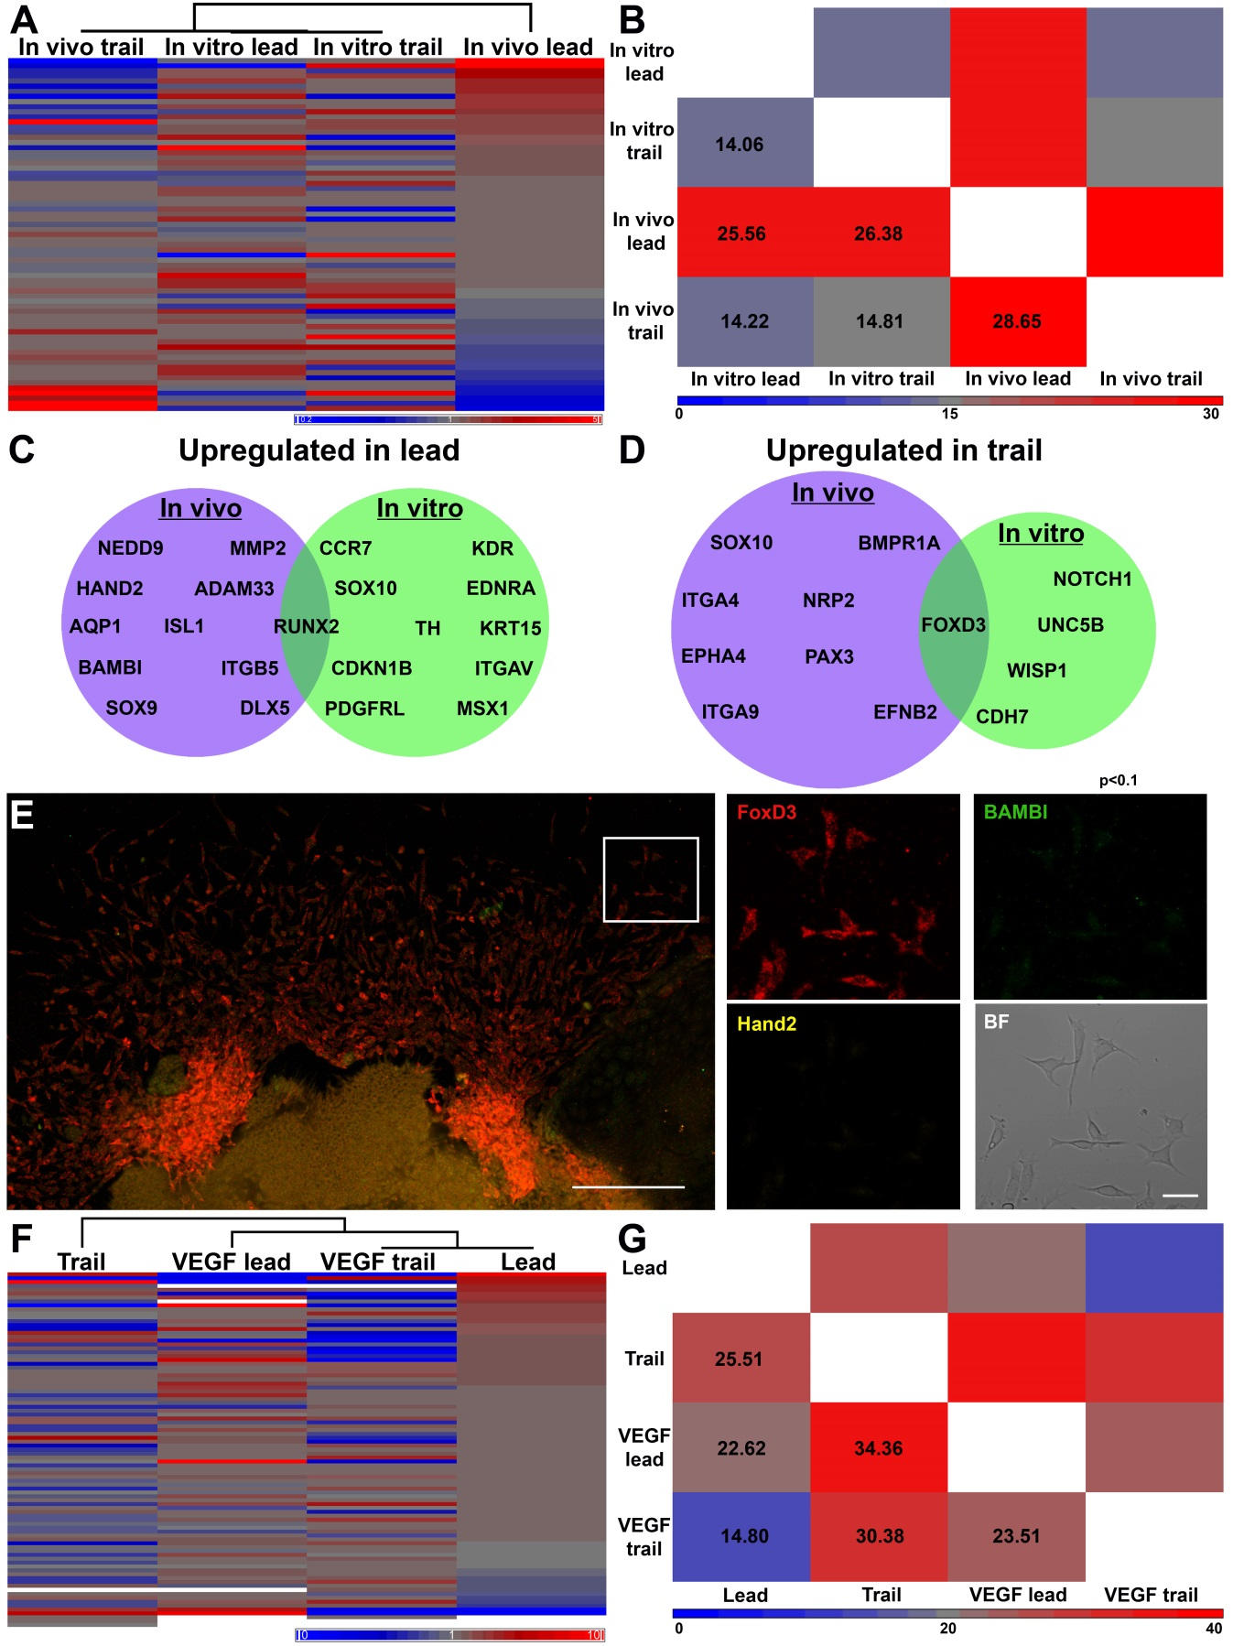

Figure 2

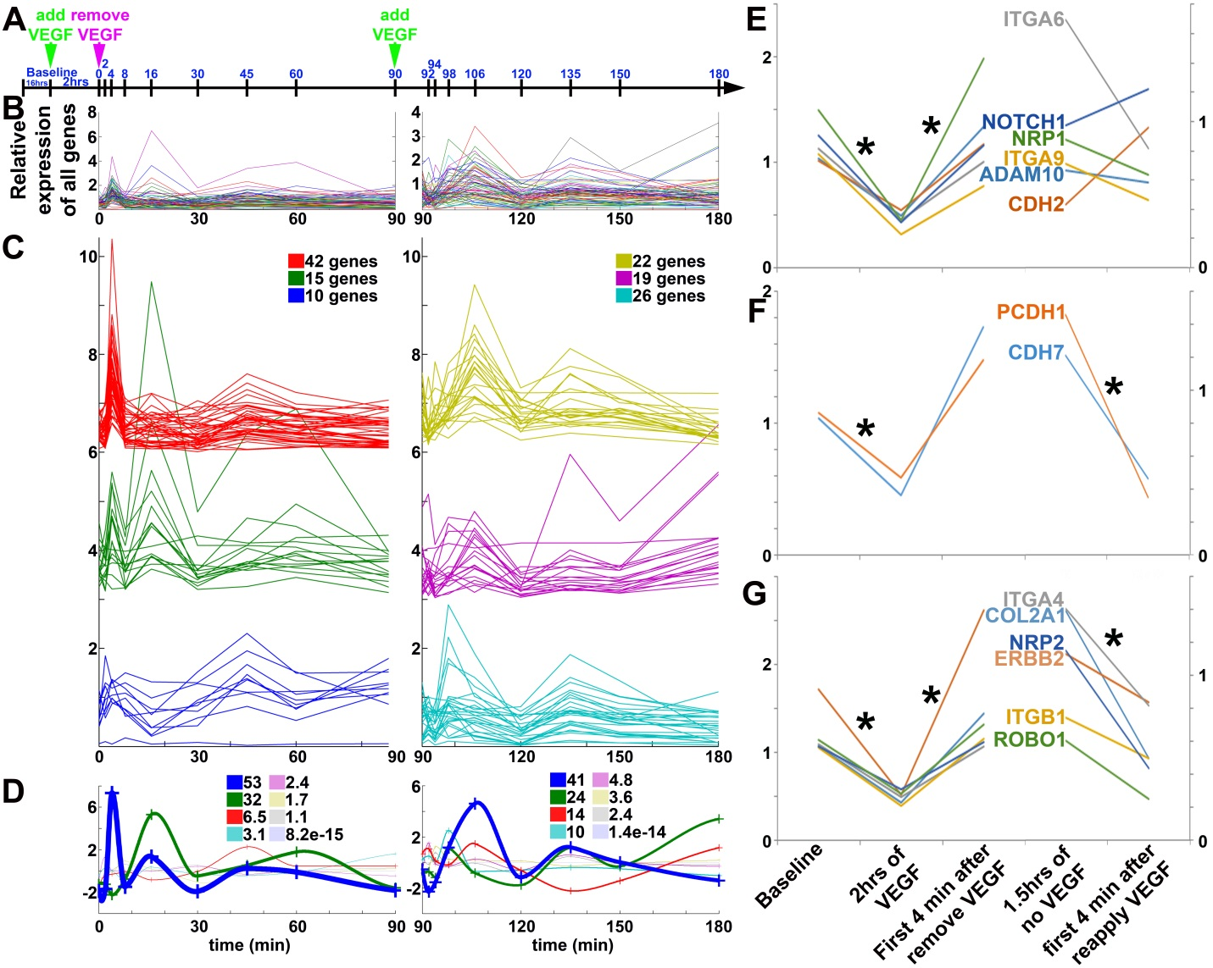

Figure 4

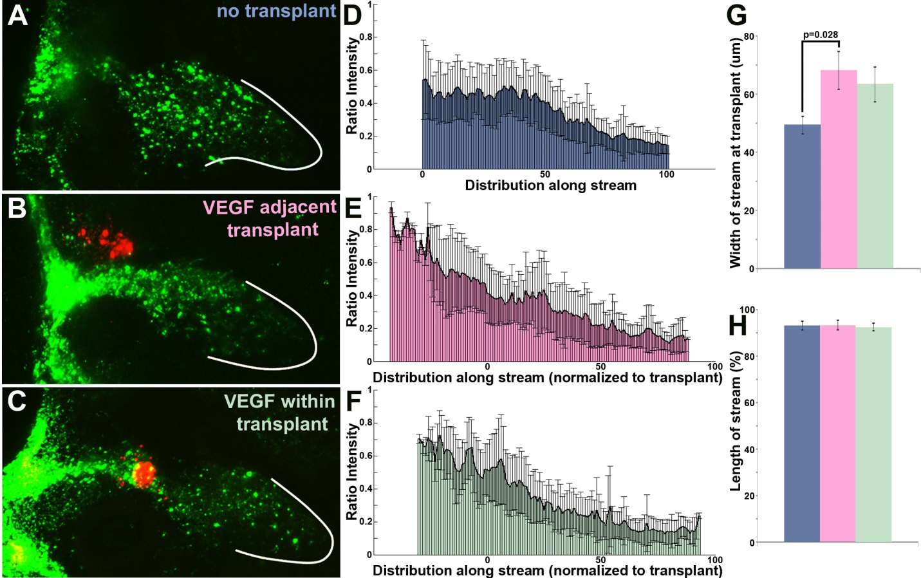

Figure 5

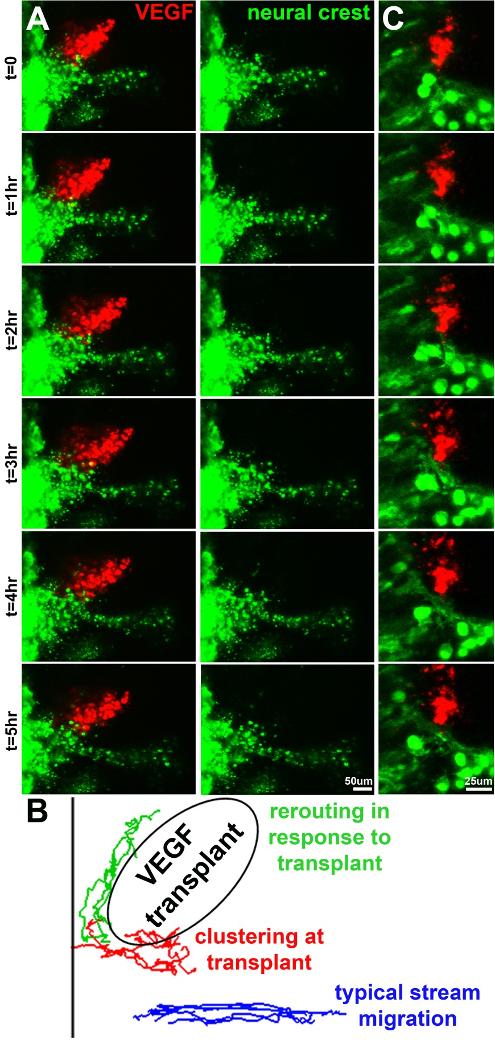

Figure 6

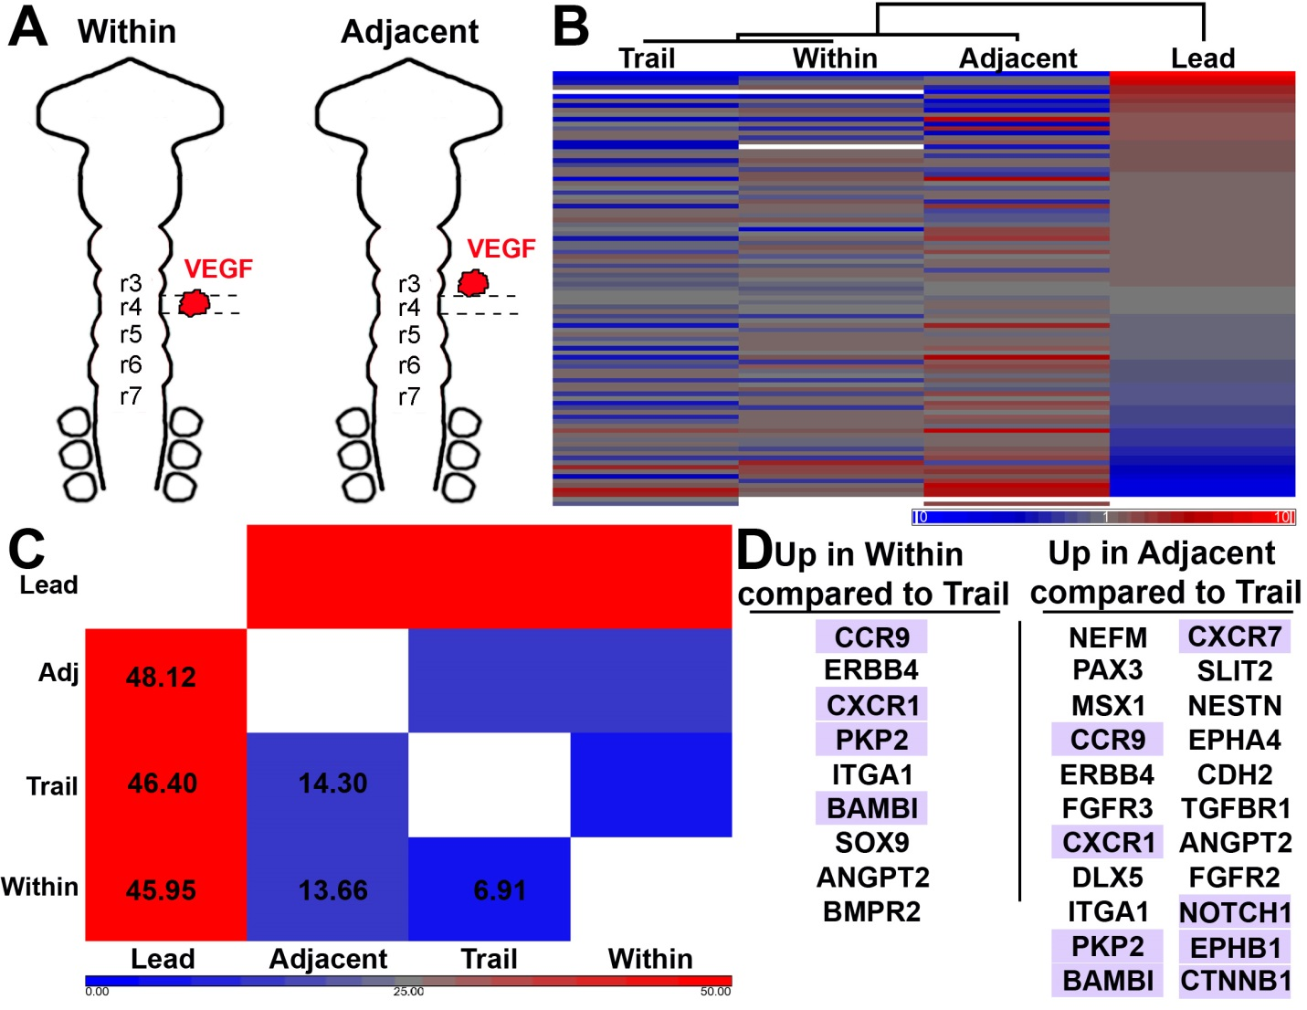

Figure 8

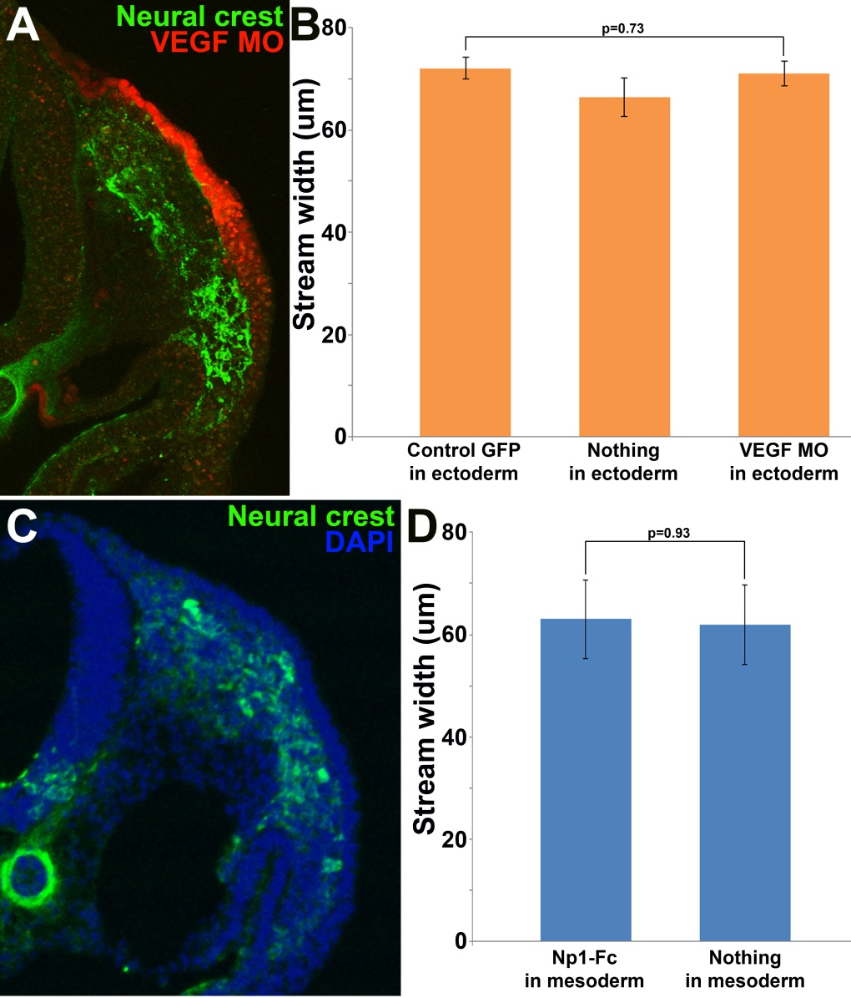

Figure 9

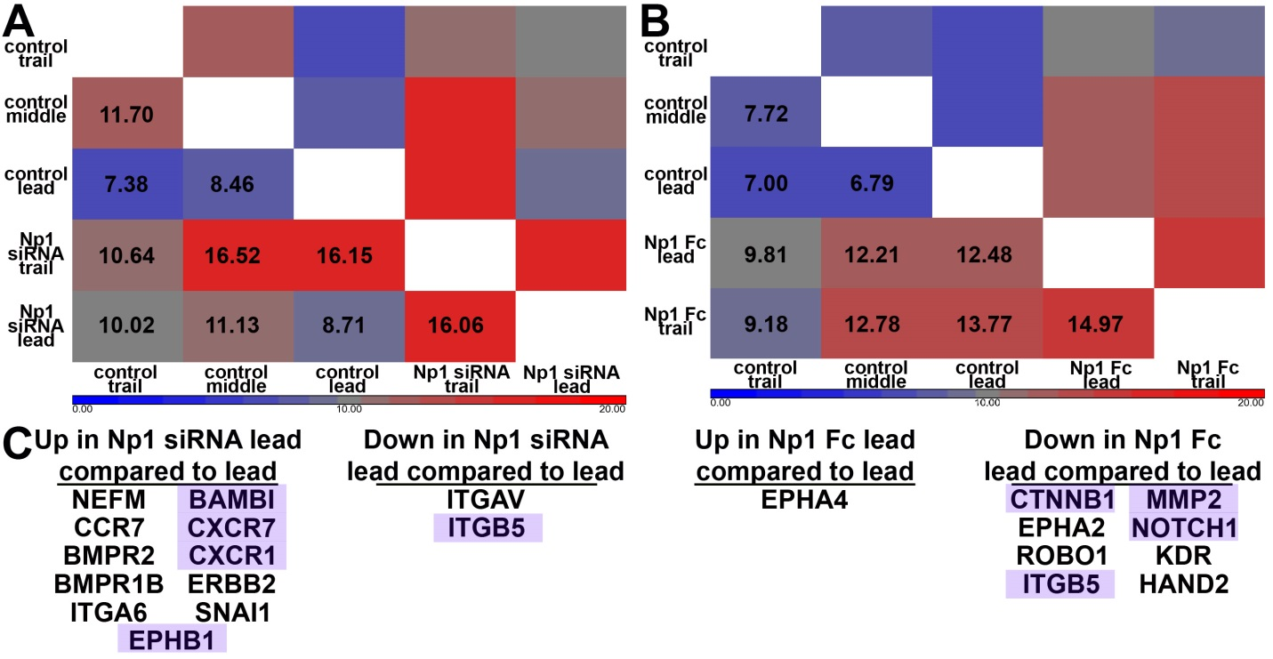

Table 1- genes downregulated upon initial exposure to VEGF

|  |  |
| --- | --- |
| ADAM10 | ITGA9 |
| CDH2 | ITGB1 |
| CDH7 | NOTCH1 |
| COL2A1 | NRP1 |
| ERBB2 | NRP2 |
| FGFR1 | PCDH1 |
| FOXD3 | ROBO1 |
| ITGA4 | SPON1 |
| ITGA6 | TGFBR1 |

**References**

**Alfandari, D., Cousin, H. and Marsden, M.** (2010). Mechanism of Xenopus cranial neural crest cell migration. *Cell Adh Migr* **4**, 553-60.

**Bron, R., Eickholt, B. J., Vermeren, M., Fragale, N. and Cohen, J.** (2004). Functional knockdown of neuropilin-1 in the developing chick nervous system by siRNA hairpins phenocopies genetic ablation in the mouse. *Dev Dyn* **230**, 299-308.

**Chapman, S. C., Collignon, J., Schoenwolf, G. C. and Lumsden, A.** (2001). Improved method for chick whole-embryo culture using a filter paper carrier. *Dev Dyn* **220**, 284-9.

**Choi, H. M., Chang, J. Y., Trinh le, A., Padilla, J. E., Fraser, S. E. and Pierce, N. A.** (2010). Programmable in situ amplification for multiplexed imaging of mRNA expression. *Nat Biotechnol* **28**, 1208-12.

**Clay, M. R. and Halloran, M. C.** (2010). Control of neural crest cell behavior and migration: Insights from live imaging. *Cell Adh Migr* **4**, 586-94.

**Gammill, L. S. and Roffers-Agarwal, J.** (2010). Division of labor during trunk neural crest development. *Dev Biol* **344**, 555-65.

**Hamburger, V. and Hamilton, H. L.** (1951). A series of normal stages in the development of the chick embryo. *J Morphol* **88**, 49-92.

**Kirby, M. L. and Hutson, M. R.** (2010). Factors controlling cardiac neural crest cell migration. *Cell Adh Migr* **4**, 609-21.

**Klymkowsky, M. W., Rossi, C. C. and Artinger, K. B.** (2010). Mechanisms driving neural crest induction and migration in the zebrafish and Xenopus laevis. *Cell Adh Migr* **4**, 595-608.

**Kulesa, P. M., Bailey, C. M., Kasemeier-Kulesa, J. C. and McLennan, R.** (2010). Cranial neural crest migration: new rules for an old road. *Dev Biol* **344**, 543-54.

**Kulesa, P. M. and Gammill, L. S.** (2010). Neural crest migration: patterns, phases and signals. *Dev Biol* **344**, 566-8.

**Lake, J. I. and Heuckeroth, R. O.** (2013). Enteric nervous system development: migration, differentiation, and disease. *Am J Physiol Gastrointest Liver Physiol* **305**, G1-24.

**McKinney, M. C., Fukatsu, K., Morrison, J., McLennan, R., Bronner, M. E. and Kulesa, P. M.** (2013). Evidence for dynamic rearrangements but lack of fate or position restrictions in premigratory avian trunk neural crest. *Development* **140**, 820-30.

**McLennan, R., Dyson, L., Prather, K. W., Morrison, J. A., Baker, R. E., Maini, P. K. and Kulesa, P. M.** (2012). Multiscale mechanisms of cell migration during development: theory and experiment. *Development* **139**, 2935-44.

**McLennan, R. and Kulesa, P. M.** (2007). In vivo analysis reveals a critical role for neuropilin-1 in cranial neural crest cell migration in chick. *Dev Biol* **301**, 227-39.

**McLennan, R., Teddy, J. M., Kasemeier-Kulesa, J. C., Romine, M. H. and Kulesa, P. M.** (2010). Vascular endothelial growth factor (VEGF) regulates cranial neural crest migration in vivo. *Dev Biol* **339**, 114-25.

**Newgreen, D. F., Dufour, S., Howard, M. J. and Landman, K. A.** (2013). Simple rules for a "simple" nervous system? Molecular and biomathematical approaches to enteric nervous system formation and malformation. *Dev Biol* **382**, 305-19.

**Perris, R. and Perissinotto, D.** (2000). Role of the extracellular matrix during neural crest cell migration. *Mech Dev* **95**, 3-21.

**Powell, D. R., Blasky, A. J., Britt, S. G. and Artinger, K. B.** (2013). Riding the crest of the wave: parallels between the neural crest and cancer in epithelial-to-mesenchymal transition and migration. *Wiley Interdiscip Rev Syst Biol Med* **5**, 511-22.

**Prud'homme, G. J. and Glinka, Y.** (2012). Neuropilins are multifunctional coreceptors involved in tumor initiation, growth, metastasis and immunity. *Oncotarget* **3**, 921-39.

**Theveneau, E. and Mayor, R.** (2012). Neural crest migration: interplay between chemorepellents, chemoattractants, contact inhibition, epithelial-mesenchymal transition, and collective cell migration. *Wiley Interdiscip Rev Dev Biol* **1**, 435-45.

**Uriu, K., Morelli, L. G. and Oates, A. C.** (2014). Interplay between intercellular signaling and cell movement in development. *Semin Cell Dev Biol*.